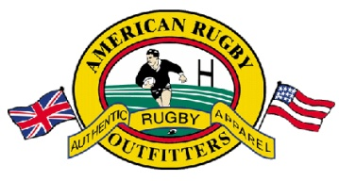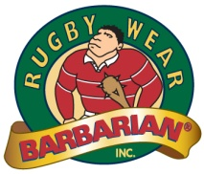

**Return Authorization #: __________________________**

American Rugby Outfitters is America's leading Authentic Rugby Team Apparel, Rugby Jerseys & Gear/Equipment distributor in America. We stand by our products and expect nothing less than perfection. Since our inception in 1985, we have been the leaders in developing new innovative ideas for rugby gear, team apparel collections and Authentic Rugby Jerseys. If you have received a defective item (i.e. stitching defect, tear in the material), the incorrect size or order, please contact us immediately. We will work with you to ensure your satisfaction.

**Our Guarantee**  
We sell the highest quality products and describe them with manufacturer's specifications. We use these items ourselves. You must be fully satisfied with your merchandise or you can request a refund. If for any reason you are not completely satisfied, send back the merchandise in question with proof of purchase after receiving your return authorization #. We will inspect the item and make an exchange or refund. For non-defective items or items ordered incorrectly our restocking fee is 15%.

**Return Information**  
Your return must be in original condition (unwashed or laundered) with the tags still attached in resalable form, and sent back in a timely fashion **(delivered less than 30 days ago)** for us to process your request. You are responsible for the cost of returning it to us. Shipping costs are non-refundable. Please do not attempt to return your merchandise that does not qualify with our policies as we will not be able to process your request and cannot ship the items back to you.

**Exchanges**If you are exchanging merchandise, please fill out this completed form, and include a return authorization # (Please call us for this) You are responsible for the cost of returning it to us, unless it was our oversight. Original shipping costs are   
non-refundable. You also will be charged for shipping the new item you are exchangingfor.

**1-800-GO-RUGBY** (800-467-8429)  
Just call and we will gladly help you with any order.

**Thank You For Your Business!**

www.AmericanRugby.com | www.RugbyGear.com | www.USARugby.com

**America's #1 Rugby Jersey Supplier Since 1985**

**Reason for return:**  
(check all that apply)

* too big
* too small
* I ordered the wrong item
* wrong item shipped
* unwanted
* returning a gift
* defective
* other: ________________

__________________________

__________________________

**Items Returning:  
______________________________**

**______________________________**

**______________________________**

**______________________________**

**Items Requesting:**

**______________________________**

**______________________________**

**______________________________**

**Name: __________________________**

**Address: ________________________**

**________________________________**

**________________________________**

**Phone: __________________________**

**Signature: _______________________**

**Return address:**American Rugby Outfitters  
Attn: Returns Dept.  
1159 Tower Road  
Schaumburg, IL 60173